**Visual Basic.NET Lab**

**Part - b**

5. Design a VB interface containing

a. A picture box whose picture should be changed every 5 second (use 5 pictures).

b. Textboxes to display date & time and day greeting based on time. Time has to be changed every second automatically.

c. Use scrollbars to change font size and background color (RGB) of the textbox that shows greeting. [Use timer, scrollbars]

(Marks distribution: Interfaces and setting properties 6, Coding 10, Output 4)

|  |  |  |
| --- | --- | --- |
| **Object** | **Property** | **Description** |
| Label1 | Name | Label1 |
| Text | program to display various pictures and date time and greeting |
| Label2 | Name | Label2 |
| Text | Date |
| Label3 | Name | Label3 |
| Text | Time |
| Label4 | Name | Label4 |
| Text | greet |
| Label5 | Name | Label5 |
| Text | Pic your colour |
| Label6 | Name | Label5 |
| Text | RED |
| Label7 | Name | Label5 |
| Text | GREEN |
| Label8 | Name | Label5 |
| Text | BLUE |
| Label9 | Name | Label5 |
| Text | Change font size |
| Text | click to change color |
| TextBox1 | Name | TextDate |
| Text | Null |
| TextBox2 | Name | TextTime |
| Text | Null |
| TextBox3 | Name | TextGreet |
| Text | Null |
| Button1 | Name | Button1 |
| Text | end |
| VScrollBar1 | Name | VScrollBar1 |
| HScrollBar1 | Name | HScrollBar1 |
| HScrollBar2 | Name | HScrollBar2 |
| HScrollBar3 | Name | HScrollBar3 |
| PictureBox1 | Name | PictureBox1 |
| DateTimePicker1 | Name | DateTimePicker1 |
| Timer1 | Name | Timer1 |
| Timer2 | Name | Timer2 |

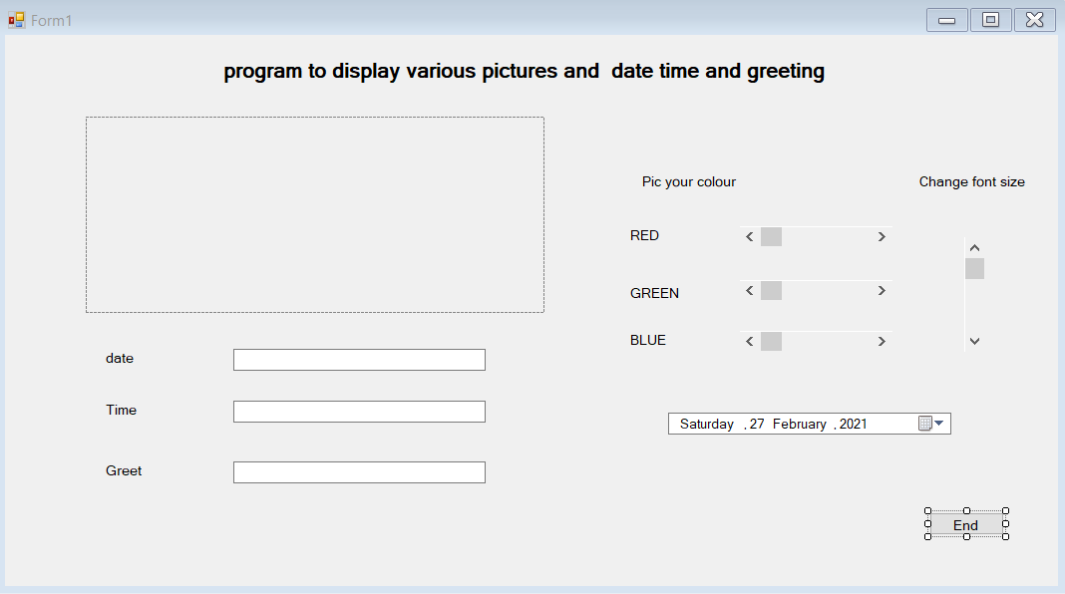

Code:

Public Class Form1

Dim i As Integer

Dim pic() As String = {"C:\BCA\3rd sem\Lab\VB_Dot_Net\images\photo2.jpg", "C:\BCA\3rd sem\Lab\VB_Dot_Net\images\photo3.jpg", "C:\BCA\3rd sem\Lab\VB_Dot_Net\images\photo4.jpg", "C:\BCA\3rd sem\Lab\VB_Dot_Net\images\photo5.jpg", "C:\BCA\3rd sem\Lab\VB_Dot_Net\images\photo1.jpg"}

Private Sub Form1_Load(ByVal sender As System.Object, ByVal e As System.EventArgs) Handles MyBase.Load

Timer2.Enabled = True

i = 0

PictureBox1.Image = Image.FromFile(pic(i))

Timer1.Interval = 5000

Timer1.Enabled = True

VScrollBar1.Minimum = 8

TextDate.Text = DateTimePicker1.Value.ToShortDateString()

TextTime.Text = DateTimePicker1.Value.ToShortDateString()

If DateTimePicker1.Value.Hour <= 12 Then

TextGreet.Text = "GOOD MORNING"

ElseIf DateTimePicker1.Value.Hour >= 12 Then

TextGreet.Text = "GOOD AFTERNOON"

ElseIf DateTimePicker1.Value.Hour <= 19 Then

TextGreet.Text = "GOOD EVENING"

Else

TextGreet.Text = "GOOD NIGHT"

End If

End Sub

Private Sub Timer1_Tick(ByVal sender As System.Object, ByVal e As System.EventArgs) Handles Timer1.Tick

PictureBox1.Image = Image.FromFile(pic(i))

i = i + 1

If i > 4 Then

i = 0

End If

End Sub

Private Sub Button1_Click(ByVal sender As System.Object, ByVal e As System.EventArgs) Handles Button1.Click

End

End Sub

Private Sub HScrollBar1_Scroll(ByVal sender As System.Object, ByVal e As System.Windows.Forms.ScrollEventArgs) Handles HScrollBar1.Scroll

Dim r, g, b As Integer

r = Me.HScrollBar1.Value

g = Me.HScrollBar2.Value

b = Me.HScrollBar3.Value

TextGreet.ForeColor = Color.FromArgb(r, g, b)

End Sub

Private Sub VScrollBar1_Scroll(ByVal sender As System.Object, ByVal e As System.Windows.Forms.ScrollEventArgs) Handles VScrollBar1.Scroll

Me.TextGreet.Font = New Font(TextGreet.Font.Style, VScrollBar1.Value)

End Sub

Private Sub HScrollBar3_Scroll(ByVal sender As System.Object, ByVal e As System.Windows.Forms.ScrollEventArgs) Handles HScrollBar3.Scroll

Dim r, g, b As Integer

r = Me.HScrollBar1.Value

g = Me.HScrollBar2.Value

b = Me.HScrollBar3.Value

TextGreet.ForeColor = Color.FromArgb(r, g, b)

End Sub

Private Sub HScrollBar2_Scroll(ByVal sender As System.Object, ByVal e As System.Windows.Forms.ScrollEventArgs) Handles HScrollBar2.Scroll

Dim r, g, b As Integer

r = Me.HScrollBar1.Value

g = Me.HScrollBar2.Value

b = Me.HScrollBar3.Value

TextGreet.ForeColor = Color.FromArgb(r, g, b)

End Sub

Private Sub Timer2_Tick(ByVal sender As System.Object, ByVal e As System.EventArgs) Handles Timer2.Tick

TextTime.Text = Date.Now.ToString("hh:mm:ss")

End Sub

End Class

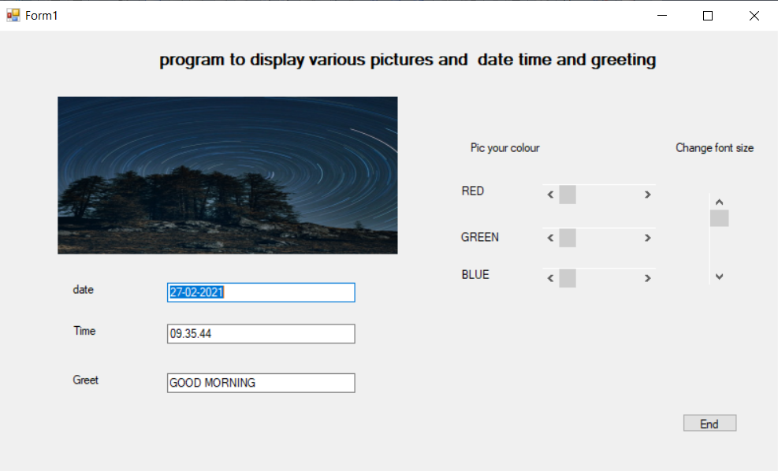

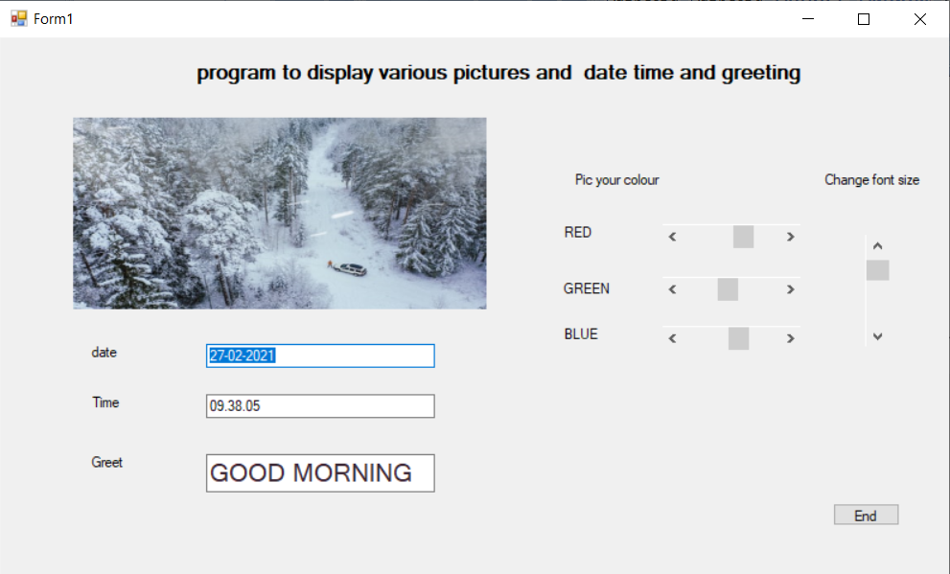

6. Design a VB interface to add, remove, search and clear the items in a combo box. The item name to be added, removed or searched can be accepted through input box. Use a general procedure to find the existence of item before deleting or while searching. (Marks distribution: Interfaces 3, Procedure 4, Adding 3, searching 2, removing 3, clear 1, Output 4)

|  |  |  |
| --- | --- | --- |
| **Object** | **Property** | **Description** |
| Button1 | Name | Button1 |
| Text | Add item |
| Button2 | Name | Button2 |
| Text | Remove item |
| Button3 | Name | Button3 |
| Text | Search item |
| Button4 | Name | Button4 |
| Text | Clear items |
| Button5 | Name | Button5 |
| Text | Exit |
| ComboBox1 | Name | ComboBox1 |
| Text | Null |

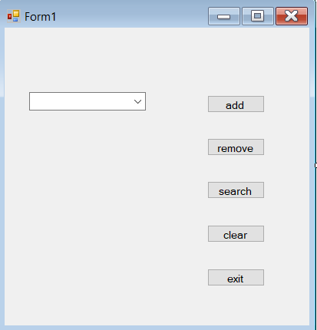

Code:

Public Class Form1

Dim item_name As String

Dim position As Integer

Private Sub Button1_Click(ByVal sender As System.Object, ByVal e As System.EventArgs) Handles Button1.Click

item_name = InputBox("enter item name to add")

ComboBox1.Items.Add(item_name)

MsgBox("item is added")

End Sub

Private Sub Button2_Click(ByVal sender As System.Object, ByVal e As System.EventArgs) Handles Button2.Click

item_name = InputBox("enter the item name to be removed")

If ComboBox1.Items.Contains(item_name) Then

ComboBox1.Items.Remove(item_name)

MsgBox(" item is removed")

Else

MsgBox("sorry item dosen't exists")

End If

End Sub

Private Sub Button3_Click(ByVal sender As System.Object, ByVal e As System.EventArgs) Handles Button3.Click

item_name = InputBox(" enter the item name to be serached")

If ComboBox1.Items.Contains(item_name) Then

position = ComboBox1.Items.IndexOf(item_name) + 1

MsgBox("Item is present in the position " & position)

Else

MsgBox(" sorry item is not present")

End If

End Sub

Private Sub Button4_Click(ByVal sender As System.Object, ByVal e As System.EventArgs) Handles Button4.Click

ComboBox1.Items.Clear()

End Sub

Private Sub Button5_Click(ByVal sender As System.Object, ByVal e As System.EventArgs) Handles Button5.Click

End

End Sub

End Class

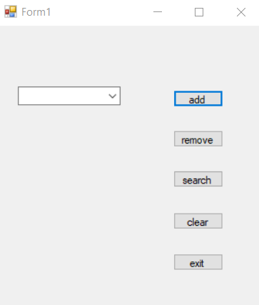

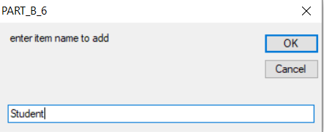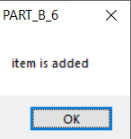

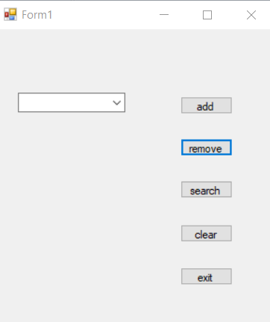

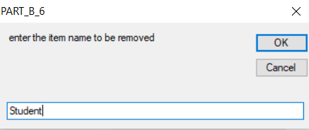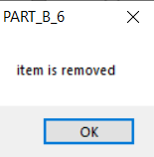

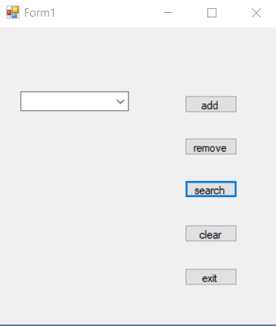

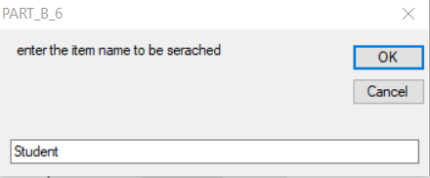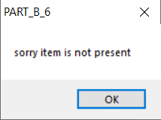

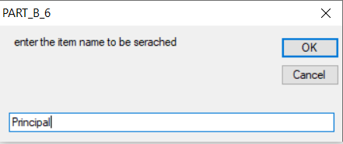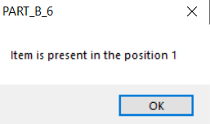

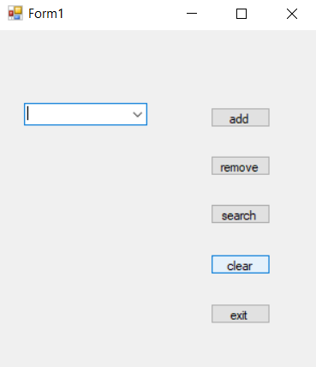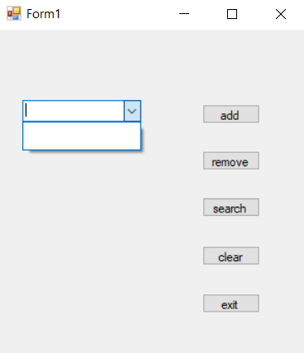

7. Design a simple calculator to perform addition, multiplication, subtraction and division. It should contain buttons for digits 0-9, clear, dot, =, +, –, *, /. Apply the validation rules to avoid entering dot more than once in a number and using – symbol between the digits. Symbol ‘–’ can be used as operator as well as for negative numbers. Any operand can be negative. “Division by zero” to be displayed if divisor is 0.

|  |  |  |
| --- | --- | --- |
| **Object** | **Property** | **Description** |
| Label1 | Name | Label1 |
| Text | Simple Calculator |
| Label1 | Name | Lbldisp |
| Text | Null |
| Panel1 | Name | Panel1 |
| Button1 | Name | Btn1 |
| Text | 1 |
| Button2 | Name | Btn2 |
| Text | 2 |
| Button3 | Name | Btn3 |
| Text | 3 |
| Button4 | Name | Btn4 |
| Text | 4 |
| Button5 | Name | Btn5 |
| Text | 5 |
| Button6 | Name | Btn6 |
| Text | 6 |
| Button7 | Name | Btn7 |
| Text | 7 |
| Button8 | Name | Btn8 |
| Text | 8 |
| Button9 | Name | Btn9 |
| Text | 9 |
| Button10 | Name | Btn0 |
| Text | 0 |
| Button11 | Name | BtnDot |
| Text | . |
| Button12 | Name | **BtnEqual** |
| Text | = |
| Button13 | Name | BtnSum |
| Text | + |
| Button14 | Name | BtnSub |
| Text | - |
| Button15 | Name | BtnMul |
| Text | * |
| Button16 | Name | BtnDevide |
| Text | / |
| Button17 | Name | BtnClear |
| Text | C |
| Button18 | Name | BtnOFF |
| Text | Off |

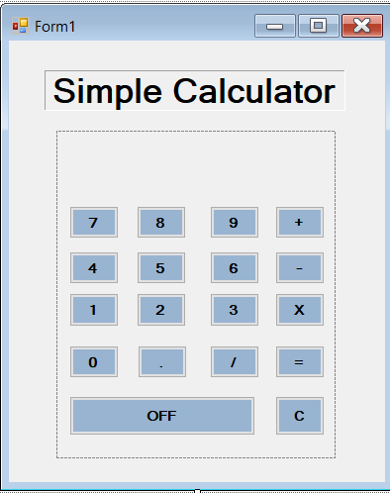

Code:

Public Class Form1

Dim operand1, operand2, result As Double

Dim operand As String

Dim cleardisplay As Boolean

Private Sub BtnSub_Click(ByVal sender As System.Object, ByVal e As System.EventArgs) Handles BtnSub.Click

If lbldisp.Text = "" Then

lbldisp.Text = "-"

cleardisplay = False

Else

operand1 = Val(lbldisp.Text)

operand = "-"

cleardisplay = True

End If

End Sub

Private Sub BtnSum_Click(ByVal sender As System.Object, ByVal e As System.EventArgs) Handles BtnSum.Click

operand1 = Val(lbldisp.Text)

operand = "+"

cleardisplay = True

End Sub

Private Sub BtnEqual_Click(ByVal sender As System.Object, ByVal e As System.EventArgs) Handles BtnEqual.Click

Dim result As Double

operand2 = Val(lbldisp.Text)

Select Case operand

Case "+"

result = operand1 + operand2

Case "-"

result = operand1 - operand2

Case "/"

If operand2 = 0 Then

lbldisp.Text = "division by zero"

Exit Sub

Else

result = operand1 / operand2

End If

Case "*"

result = operand1 * operand2

End Select

lbldisp.Text = result

End Sub

Private Sub BtnMul_Click(ByVal sender As System.Object, ByVal e As System.EventArgs) Handles BtnMul.Click

operand1 = Val(lbldisp.Text)

operand = "*"

cleardisplay = True

End Sub

Private Sub BtnDevide_Click(ByVal sender As System.Object, ByVal e As System.EventArgs) Handles BtnDevide.Click

operand1 = Val(lbldisp.Text)

operand = "/"

cleardisplay = True

End Sub

Private Sub BtnClear_Click(ByVal sender As System.Object, ByVal e As System.EventArgs) Handles BtnClear.Click

lbldisp.Text = ""

End Sub

Private Sub BtnOFF_Click(ByVal sender As System.Object, ByVal e As System.EventArgs) Handles BtnOFF.Click

End

End Sub

Private Sub BtnDot_Click(ByVal sender As System.Object, ByVal e As System.EventArgs) Handles BtnDot.Click

If lbldisp.Text.IndexOf(".") > 0 Then

Exit Sub

Else

lbldisp.Text = lbldisp.Text & sender.text

End If

End Sub

Private Sub Btn1_Click(ByVal sender As System.Object, ByVal e As System.EventArgs) Handles Btn1.Click,

Btn2.Click, Btn3.Click, Btn4.Click, Btn5.Click, Btn6.Click, Btn7.Click, Btn8.Click,

Btn9.Click, Btn0.Click

If cleardisplay Then

lbldisp.Text = " "

End If

cleardisplay = False

lbldisp.Text = lbldisp.Text + sender.text

End Sub

End Class

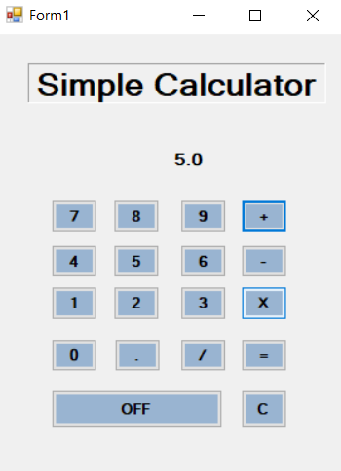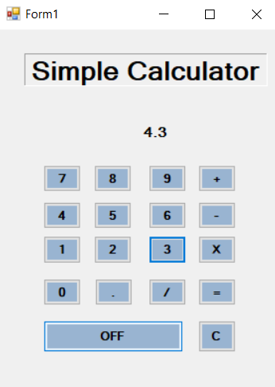

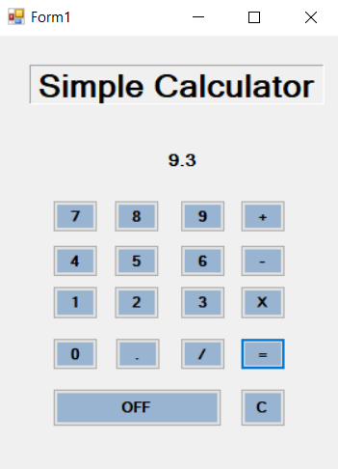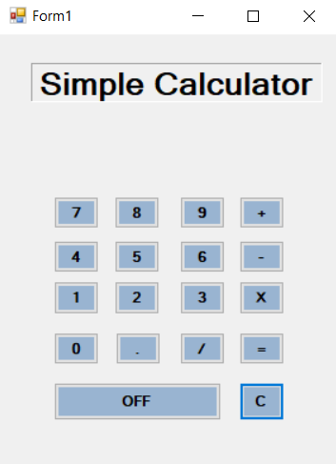

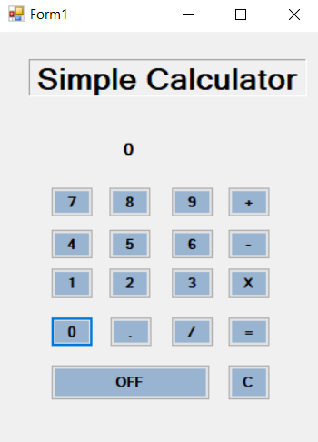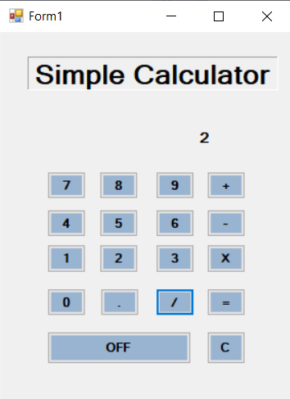

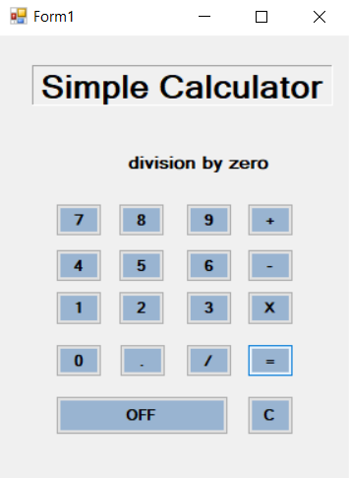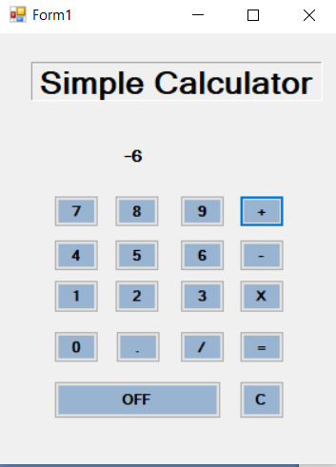

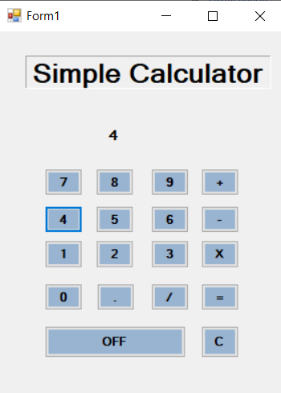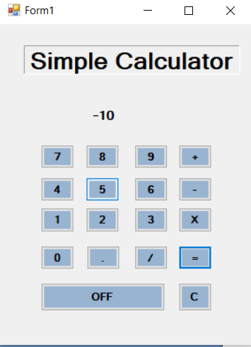

8. Design VB interface to conduct simple multiple choice Quiz with at least 5 questions. For selecting the answers, use combo box and radio buttons for few questions. One question can be answered only once. Show the total score through the message box whenever the user wishes to see his score in between the competition. Any question can be attempted randomly. Design can be as shown below.

|  |  |  |
| --- | --- | --- |
| **Object** | **Property** | **Description** |
| Label1 | Name | Label1 |
| Text | Quiz Competition |
| Label2 | Name | Label2 |
| Text | Click the button to attempt. |
| Label3 | Name | Label3 |
| Text | One question can be attempted only once |
| Label4 | Name | Label4 |
| Text | Each correct answer gets 20 marks |
| Label5 | Name | lblqn |
| Text | Label5 |
| Button1 | Name | btnq1 |
| Text | Qn1 |
| Button2 | Name | Btnq2 |
| Text | Qn2 |
| Button3 | Name | Btnq3 |
| Text | Qn3 |
| Button4 | Name | Btnq4 |
| Text | Qn4 |
| Button5 | Name | Btnq5 |
| Text | Qn5 |
| Button6 | Name | Btnscore |
| Text | Score |
| Button7 | Name | Btnrestart |
| Text | Restart |
| Button8 | Name | Btnexit |
| Text | End |
| Button9 | Name | Btnsubmit |
| Text | Submit answer |
| GroupBox1 | Name | GroupBox1 |
| Text | -- |
| GroupBox2 | Name | GroupBox2 |
| Text | Select your answer |
| GroupBox3 | Name | GroupBox3 |
| Text | Select your answer |
| ComboBox1 | Name | ComboBox1 |
| Text | Null |
| RadioButton1 | Name | RadioButton1 |
| Text | RadioButton1 |
| RadioButton2 | Name | RadioButton2 |
| Text | RadioButton2 |
| RadioButton3 | Name | RadioButton3 |
| Text | RadioButton3 |
| RadioButton4 | Name | RadioButton4 |
| Text | RadioButton4 |

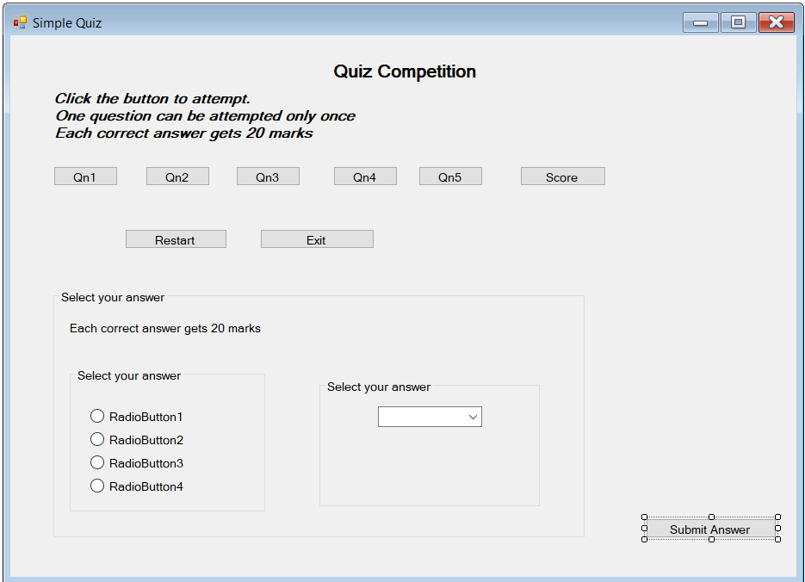

Code:

Public Class Form1

Public score, qno As Integer

Function load()

lblqn.Text = ""

GroupBox1.Text = ""

Btnq1.Enabled = True

Btnq2.Enabled = True

Btnq3.Enabled = True

Btnq4.Enabled = True

Btnq5.Enabled = True

score = 0

GroupBox2.Visible = False

GroupBox3.Visible = False

End Function

Private Sub Form1_Load(ByVal sender As System.Object, ByVal e As System.EventArgs) Handles MyBase.Load

load()

End Sub

Private Sub Btnq1_Click(ByVal sender As System.Object, ByVal e As System.EventArgs) Handles Btnq1.Click

GroupBox1.Text = Btnq1.Text

GroupBox3.Visible = False

qno = 1

lblqn.Text = "'OS' computer abbreviation usually means ?"

GroupBox2.Visible = True

RadioButton1.Text = "Order of Significance"

RadioButton2.Text = "Open Software"

RadioButton3.Text = "Operating System"

RadioButton4.Text = "Optical Sensor"

Btnq1.Enabled = False

End Sub

Private Sub Btnq2_Click(ByVal sender As System.Object, ByVal e As System.EventArgs) Handles Btnq2.Click

GroupBox1.Text = Btnq2.Text

GroupBox3.Visible = False

qno = 2

lblqn.Text = "'.MOV' extension refers usually to what kind of file?"

GroupBox2.Visible = True

RadioButton1.Text = "Image file"

RadioButton2.Text = "Animation/movie file"

RadioButton3.Text = "Audio file"

RadioButton4.Text = "MS Office Document"

Btnq2.Enabled = False

End Sub

Private Sub Btnq3_Click(ByVal sender As System.Object, ByVal e As System.EventArgs) Handles Btnq3.Click

GroupBox1.Text = Btnq3.Text

GroupBox3.Visible = False

qno = 3

lblqn.Text = "Which is a type of Electrically-Erasable Programmable Read-Only Memory?"

GroupBox2.Visible = True

RadioButton1.Text = "Flash"

RadioButton2.Text = "Flange"

RadioButton3.Text = "Fury"

RadioButton4.Text = "FRAM"

Btnq3.Enabled = False

End Sub

Private Sub Btnq4_Click(ByVal sender As System.Object, ByVal e As System.EventArgs) Handles Btnq4.Click

GroupBox3.Visible = True

GroupBox2.Visible = False

GroupBox1.Text = Btnq4.Text

qno = 4

ComboBox1.Text = ""

ComboBox1.Items.Clear()

lblqn.Text = "Who developed Yahoo?"

ComboBox1.Items.Add("Dennis Ritchie & Ken Thompson")

ComboBox1.Items.Add("David Filo & Jerry Yang")

ComboBox1.Items.Add("Vint Cerf & Robert Kahn")

ComboBox1.Items.Add("Steve Case & Jeff Bezos")

Btnq4.Enabled = False

End Sub

Private Sub Btnq5_Click(ByVal sender As System.Object, ByVal e As System.EventArgs) Handles Btnq5.Click

GroupBox3.Visible = True

GroupBox2.Visible = False

GroupBox1.Text = Btnq5.Text

qno = 5

ComboBox1.Text = ""

ComboBox1.Items.Clear()

lblqn.Text = "What does the term PLC stand for?"

ComboBox1.Items.Add("Programmable Lift Computer")

ComboBox1.Items.Add("Program List Control")

ComboBox1.Items.Add("Programmable Logic Controller")

ComboBox1.Items.Add("Piezo Lamp Connector")

Btnq5.Enabled = False

End Sub

Private Sub Btnscore_Click(ByVal sender As System.Object, ByVal e As System.EventArgs) Handles Btnscore.Click

MsgBox("Your score is " & score)

End Sub

Private Sub Btnexit_Click(ByVal sender As System.Object, ByVal e As System.EventArgs) Handles Btnexit.Click

End

End Sub

Private Sub Btnrestart_Click(ByVal sender As System.Object, ByVal e As System.EventArgs) Handles Btnrestart.Click

load()

End Sub

Private Sub Btnsubmit_Click(ByVal sender As System.Object, ByVal e As System.EventArgs) Handles Btnsubmit.Click

Select Case GroupBox1.Text

Case "Qn1"

If RadioButton3.Checked Then

score = score + 20

End If

Case "Qn2"

If RadioButton2.Checked Then

score = score + 20

End If

Case "Qn3"

If RadioButton1.Checked Then

score = score + 20

End If

Case "Qn4"

If ComboBox1.SelectedItem = "David Filo & Jerry Yang" Then

score = score + 20

End If

Case "Qn5"

If ComboBox1.SelectedItem = "Programmable Logic Controller" Then

score = score + 20

End If

End Select

lblqn.Text = ""

GroupBox1.Text = ""

GroupBox2.Visible = False

GroupBox3.Visible = False

End Sub

End Class

